

**Kamala Education Society’s**

PRATIBHA COLLEGE OF COMMERECE AND COMPUTER STUDIES

PUNE – 411019

A

PROJECT REPORT

ON

**“AIRLINE RESERVATION SYSTEM”**

Developed By

**Mr: SAURABH BODKE**

**AND**

**Mr: ASHISH AROTE**

T.Y.BSc(Computer Science)

In

Department Of Computer Science

Under

Savitribai Phule Pune University

2018-2019



**Kamala Education Society’s**

PRATIBHA COLLEGE OF COMMERECE AND COMPUTER STUDIES

PUNE – 411019

For Academic Year 2018-2019

Certificate

This is to certify that **Mr: SAURABH BODKE and ASHISH AROTE**  are

Students of this college. They have successfully completed their Project

Report on **“AIRLINE RESERVATION SYSTEM”** as partial fulfillment of the Course T.Y.BSc.(Computer Science) affiliated to Savitribai Phule Pune University

during the academic year 2018-2019.

Prof.Nilambari Kale Prof.Harshita Vachhani Dr.Babasaheb Sangle

(Project Guide) (Head of Department) (Principal)

Internal Examiner External Examiner

Date: / /

INDEX

|  |  |  |
| --- | --- | --- |
| **Sr No** | **Title** | **Page No** |
| **1** | **Introduction of the System**  **1.1 Problem Definition**  **1.2 Scope Of System**  **1.3 Advantages of the system** | **4-8** |
| **2** | **System Analysis**  **2.1 Requirement Analysis**  **2.2 Hardware And Software Requirement**  **2.3 Feasibility Study**  **2.3.1 Economical Feasibility**  **2.3.2 Operational Feasibility**  **2.3.3 Technical Feasibility** | **9-11** |
| **3** | **Data Dictionary** | **12-14** |
| **4** | **System Design**  **4.1 Entity Relationship Diagram**  **4.2 Class Diagram**  **4.3 State Chart Diagram**  **4.4 Object Diagram**  **4.5 Use Case Diagram**  **4.6 Activity Diagram**  **4.7 Sequence Diagram**  **4.8 Collaboration Diagram**  **4.9 Component Diagram**  **4.10 Deployment Diagram** | **15-25** |
| **5** | **User Manual** | **26-31** |
| **6** | **Future Enhancement** | **32** |
| **7** | **Bibliography** | **33** |

**1) INTRODUCTION OF SYSTEM**

**Airline Reservation System :**

Earlier, the Airline Reservation Systems (ARS) used to be standalone systems. Each airline had its own system, disconnected from other airlines or ticket agents, and usable only by a designated number of airline employees .Travel agents in the 1970s pushed for access to the airlines' systems. Today, air travel information is linked, stored, and retrieved by a network of Computer Reservations Systems (CRS), accessible by multiple airlines and travel agents. The global distribution system (GDS) makes for an even larger web of airline information, not only merging the buying and selling of tickets for multiple airlines, but also making the systems accessible to consumers directly. GD Portal’s and gateways on the Web allow consumers to purchase tickets directly, select seats, and even book hotels and rental cars. Airline Reservation System (ARS) in conjunction with Global Distribution System (GDS) has led to ease of airline ticketing, flight scheduling and also provided a means for customers to access and book flights from their homes. It has also increased the speed with which information about customers are retrieved and handled for flight scheduling tasks.

Airline Reservation System

(ARS) is a computerized system used to store and retrieve information and conduct transactions related to air travel. The systems was originally designed and operated by airlines, but were later extended for the use of travel agencies. Major ARS operations that book and sell tickets for multiple airlines are known as

Global Distribution Systems (GDS)

. Airlines have divested most of their direct holdings to dedicated GDS companies, who make their systems accessible to consumers through Internet gateways. Modern GD typically allows users to book hotel rooms and rental cars as well as airline tickets. It is obvious that everything that is sustainable would have to go through advancement. In science and

technology, the desire for improvement is a constant subject which triggers advancements. This is visible in every ramification and the airline industry is not an exemption. Airline Reservation Systems (ARS) used to be standalone systems. Each airline had its own system, disconnected from other airlines or ticket agents, and usable only by a designated number of airline employees.

1970s pushed for access to the airlines' systems. Today, air travel information is linked, stored, and retrieved by a network of Computer Reservations Systems (CRS), accessible by multiple airlines and travel agents. The global distribution system (GDS) makes for an even larger web of airline information, not only merging the buying and selling of tickets for multiple airlines, but also making the systems accessible to consumers directly. GDS portals and gateways on the We allow consumers to purchase tickets directly, select seats, and even book hotels and rental cars.

Scope of the System:

In the Airline Reservation System their will be Air Craft ,Sector, Flight Information, Add Schedule ,Reservation of flight ,Their will be also Cancellation of Flight

**1.1 Problem Definition:**

The absence of well-established information system to serve customer and staff has led to inconvenience.

It is not suitable for computer illiterate people.

This is basically because of the weakness of the existing system which include over reliance on paper based work.

Paper File consumes a lot of office space.

Slow recording processing and retrieval of customer details.

Accessing and sharing of information by different department is difficult due to poor information management.

**1.2 SCOPE OF SYSTEM:**

* Product listing-This module is support to identify the product by their description
* Add Product-This module is support to take the inputs from on input device
* Transaction- This module will take up transactions like reservation of flight ,
* We can Add_ update , delete _searching Flight perform all operation in system.

**1.3 Advantages of System**

* The system will keep the record of Flight Information, Customer Reservation, Sector Information.
* There will be no loss of customer record.
* It is safely saved in system and it is accessible to only Customer
* It is easy to access data.
* It will gives modification in the flight, Customer Reservation.
* The customer can schedule and confirm Flight Booking.so, the waiting time for reservation will be reduced.

**System Analysis**

**2.1 HARDWARE REQUIREMENT:**

**HARDWARE:**

Secondly we have to collect information about hardware requirement.

This information is necessary to know about the storage space and memory available for the current system.

|  |  |
| --- | --- |
| Objects | Content Used Currently |
| Hard Disc | HDD 20 GB Hard Disk Space and Above |
| Printer | INKJECT |
| Processor | PIV 2.8 GHz Processor |
| RAM | RAM 512MB and Above |

**SOFTWARE REQUIREMENT:**

Here Database is created in Postgress and JSP is used as to provide a GUI based interface.

|  |  |
| --- | --- |
| JSP | Front End |
| Postgress | Back End |
| Linux | Operating System |

**2.3 Feasibility Study :**

**2.3.1 Economical Feasibility:**

The system being developed is economic with the restaurant a

Point of view. It is cost effective in the sense that has eliminated the paper work completely. The result obtained contains minimum error and highly accurate as the data is required.

Cost Reduction: We should try to reduce manpower technical use so; there will less use of cost.

**2.3.2 Operational Feasibility:**

We provide a good system as per customer requirement with improved performance and efficiency.

It should be fit to day to day operations.

In our project we go through government and legal approval.

The system is user friendly as it is easy to operate for user.

**2.3.3Technical Feasibility:**

Ability to construct system.

1. The software we use is windows visual basic and Microsoft access.
2. We can provide maximum project size as per the customer needs.

For developing project we need 2, 3 peoples.

Each person should have their activity. Such as coding, developing, designing.

**DATA DICTIONARY**

**1.Login**

|  |  |  |  |  |
| --- | --- | --- | --- | --- |
| Sr.No | Column Name | Data Type | Constraint | Description |
| 1 | Admin_id | Character | Not NULL | Store id |
| 2 | Password | Character | Not NULL | Store password |
|  |  |  |  |  |

**2.Flights Details**

|  |  |  |  |  |
| --- | --- | --- | --- | --- |
| Sr.No | Column Name | Data Type | Constraint | Description |
| 1 | Flight_id | Character | Primary key | Store Flight id |
| 2 | Arrival | Date/Time | Not NULL | Store Arrival Time |
| 3 | Departure | Date/Time | Not NULL | Store Departure Time |
| 4 | Price | Numeric | Not NULL | Store price |
| 5 | Airline | Character | Not NULL | Store airline |
| 6 | Seats | Double | Not NULL | Store seats |
| 7 | To_city | Character | Not NULL | Store to city |
| 8 | From_city | Character | Not NULL | Store from city |
| 9 | Id | Integer | Not NULL | Store id |

1. **Book_Flight**

|  |  |  |  |  |
| --- | --- | --- | --- | --- |
| Sr.No | Column Name | Data Type | Constraint | Description |
| 1 | Transaction_id | Character | Primary key | Store id |
| 2 | Customer_id | Character | Not NULL | Store customer id |
| 3 | Price | Number | Not NULL | Store price |
| 4 | Total_cost | Numeric | Not NULL | Store cost |
| 5 | Airline | Character | Not NULL | Store airline |
| 6 | Flight_availability | Character | Not NULL | Store flight availability |
| 7 | Book_date | Integer | Not NULL | Store date |

**4.Contact us**

|  |  |  |  |  |
| --- | --- | --- | --- | --- |
| Sr.No | Column Name | Data Type | Constraint | Description |
| 1 | Name | Character | Not NULL | Store name |
| 2 | Email_address | Character | Not NULL | Store email |
| 3 | Ph_no | Numeric | Not NULL | Store phone no. |
| 4 | Message | Character | Not NULL | Store message |

**5**.Customer **Login**

|  |  |  |  |  |
| --- | --- | --- | --- | --- |
| Sr.No | Column Name | Data Type | Constraint | Description |
| 1 | Customer_id | Character | Primary key | Store id |
| 2 | Password | Character | Not NULL | Store password |

**6.Customer sign in**

|  |  |  |  |  |
| --- | --- | --- | --- | --- |
| Sr.No | Column Name | Data Type | Constraint | Description |
| 1 | Customer name | Character | Not NULL | Store name |
| 2 | Cust_id | Character | Not NULL | Store id |
| 3 | Password | Character | Not NULL | Store password |
| 4 | Confirmed | Character | Not NULL | Store confirm id |
| 5 | Email | Character | Not NULL | Store email id |
| 6 | Ph_no | Character | Not NULL | Store phone no. |
| 7 | Cust_type | Character | Not NULL | Store customer type |

**7.Payment**

|  |  |  |  |  |
| --- | --- | --- | --- | --- |
| Sr.No | Column Name | Data Type | Constraint | Description |
| 1 | Credit_card_no. | Character | Not NULL | Store card no |
| 2 | Cvv | Numeric | Not NULL | Store cvv |
| 3 | Valid date | Date | Not NULL | Store date |
| 4 | Total cost | Numeric | Not NULL | Store cost |
| 5 | Customer_id | Integer | Not NULL | Store customer id |
| 6 | Id | Integer | Not NULL | Store id |

**8.Payment id sequence**

|  |  |  |  |  |
| --- | --- | --- | --- | --- |
| Sr.No | Column Name | Data Type | Constraint | Description |
| 1 | Sequence name | Name | Primary key | Store name |
| 2 | Start value | Numeric | Not NULL | Store value |
| 3 | Increment by | Numeric | Not NULL | Store increment value |
| 4 | Max_value | Numeric | Not NULL | Store max value |
| 5 | Min_value | Numeric | Not NULL | Store min value |
| 6 | Cache value | Numeric | Not NULL | Store cache value |
| 7 | Log_cnt | Numeric | Not NULL | Store value |
| 8 | Is cycled | Boolean | Not NULL | Store value |
| 9 | Is called | Boolean | Not NULL | Store value |

**SYSTEM DESIGN**

**4.1 Entity Relationship Diagram**



**2.CLASS DIAGRAM**



**4.3 State Chart Diagram**



**4.4 Object Diagram**

**4.5 Use Case Diagram**



**4.6 Activity Diagram**



**4.7 Sequence Diagram**



**4.8 Collaboration Diagram**



**4.9 Component Diagram**



**4.10 Deployment Diagram**



**USER MANUAL**

**Sample Input & Output Screen:**

MDI Form:-

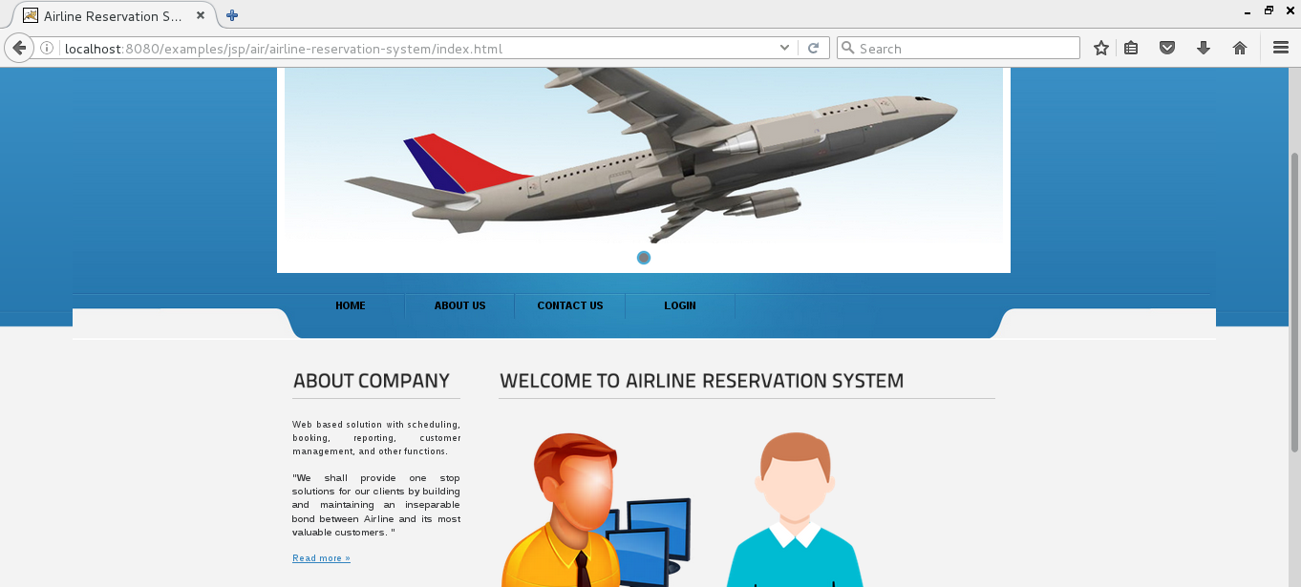

Admin Login form:-

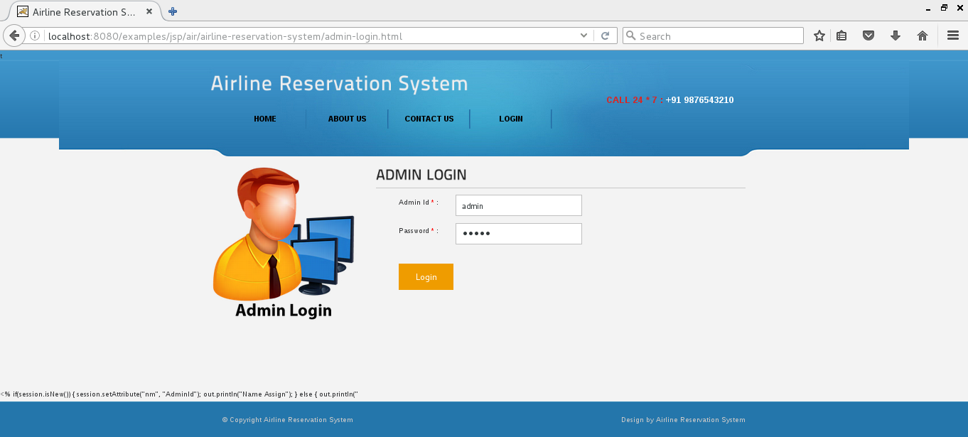

Location Master:-

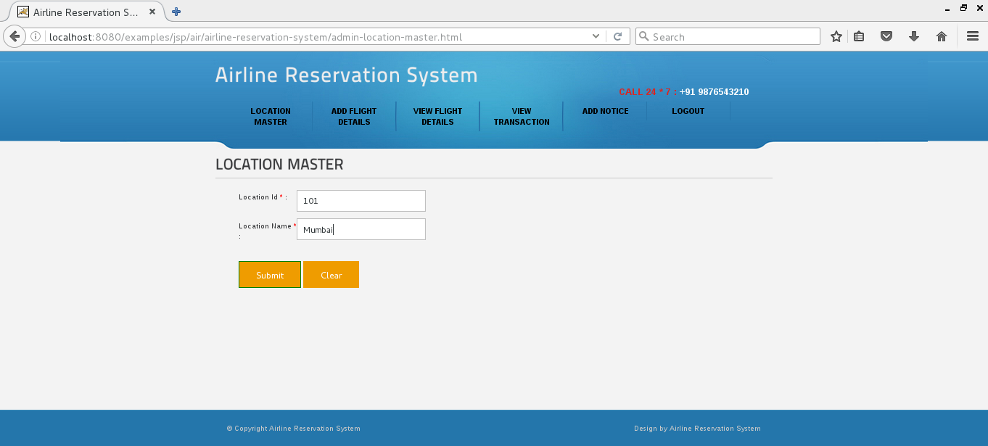

Add Flight Details:-

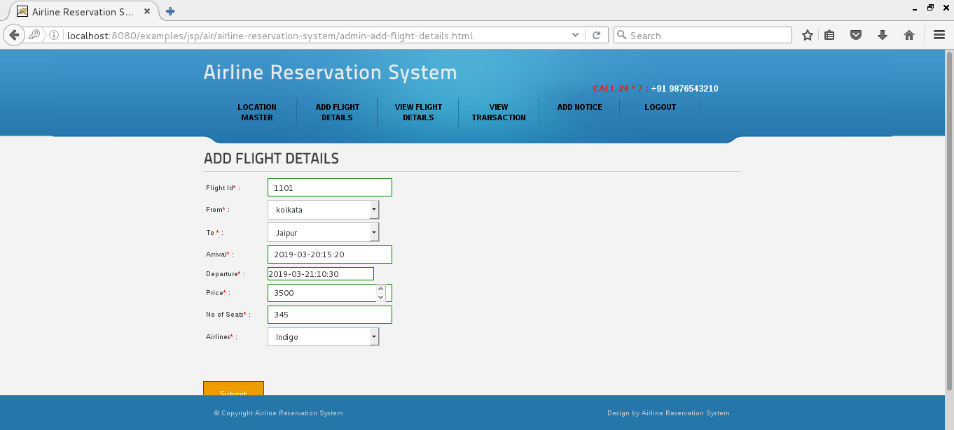

View Flight Details:-

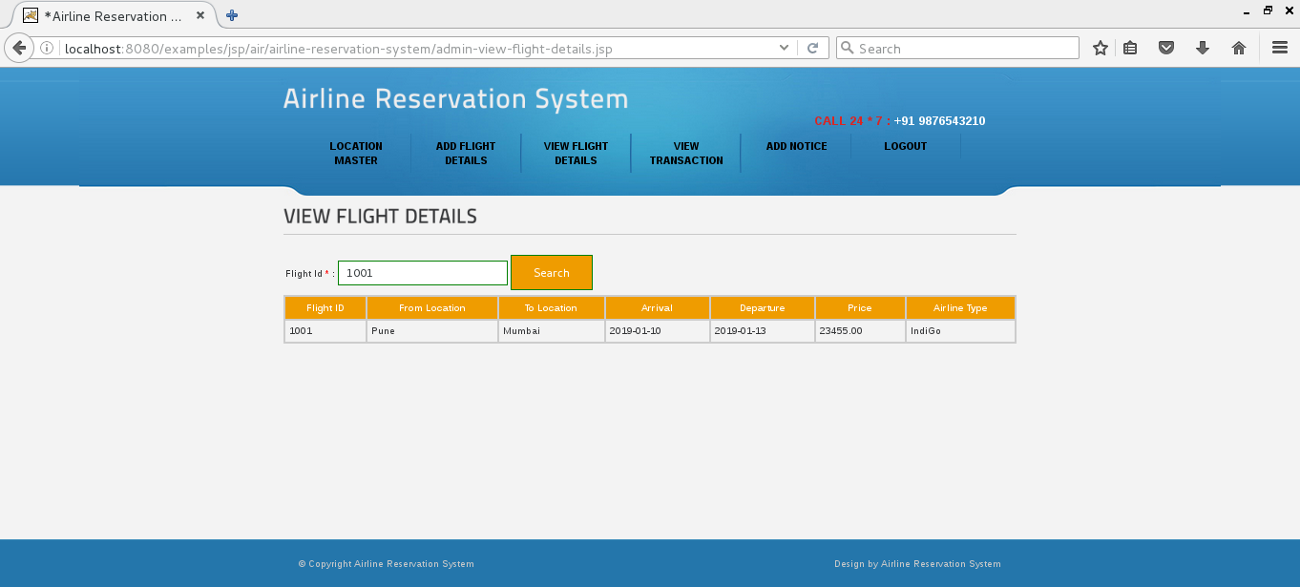

View Transction:-

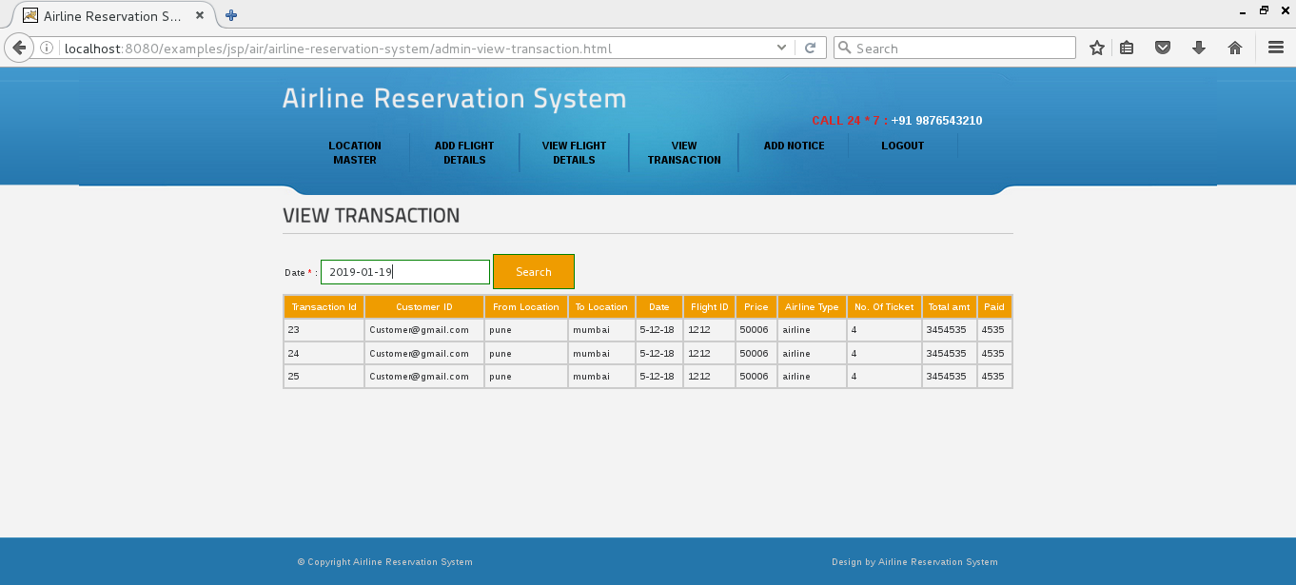

Customer Sign In form:-

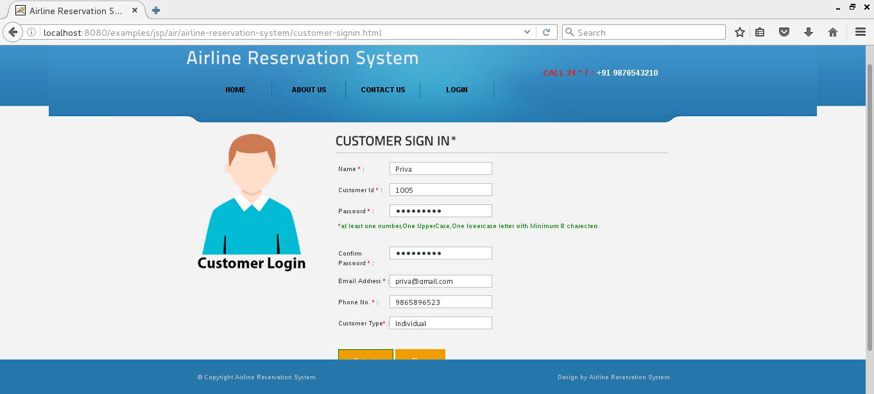

Customer Login:-

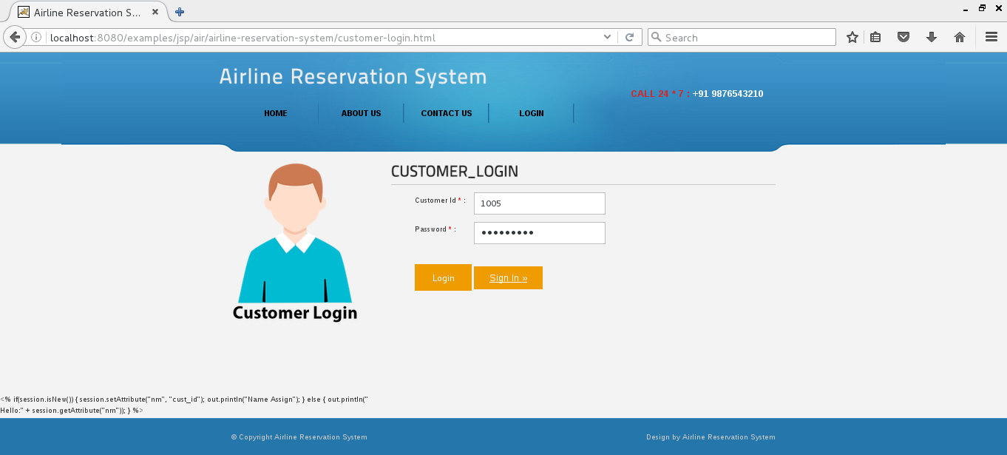

Search Flight form:-

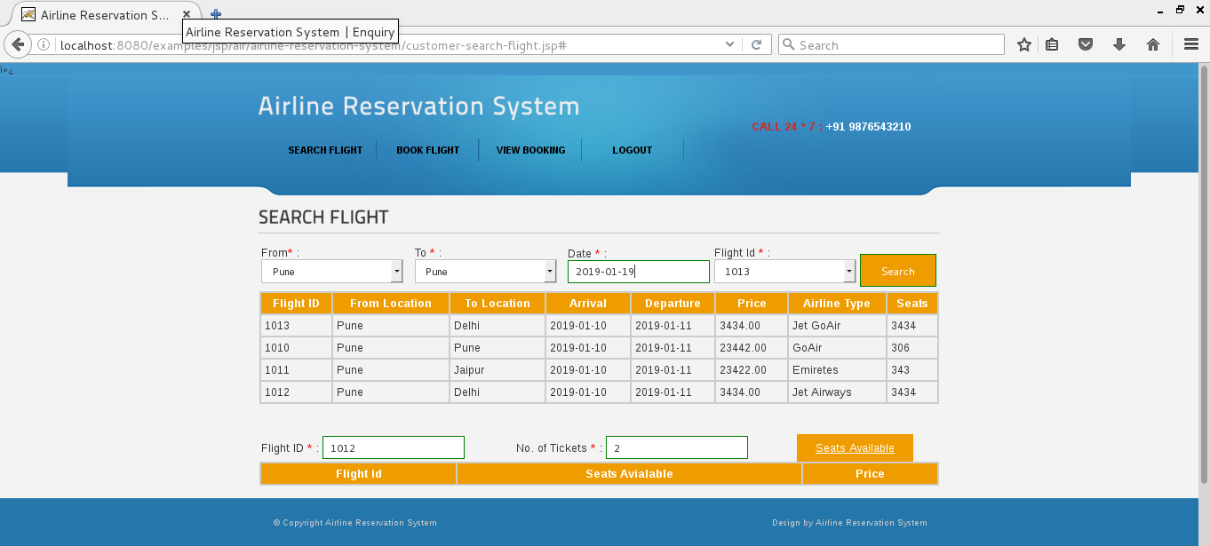

Book Flight:-

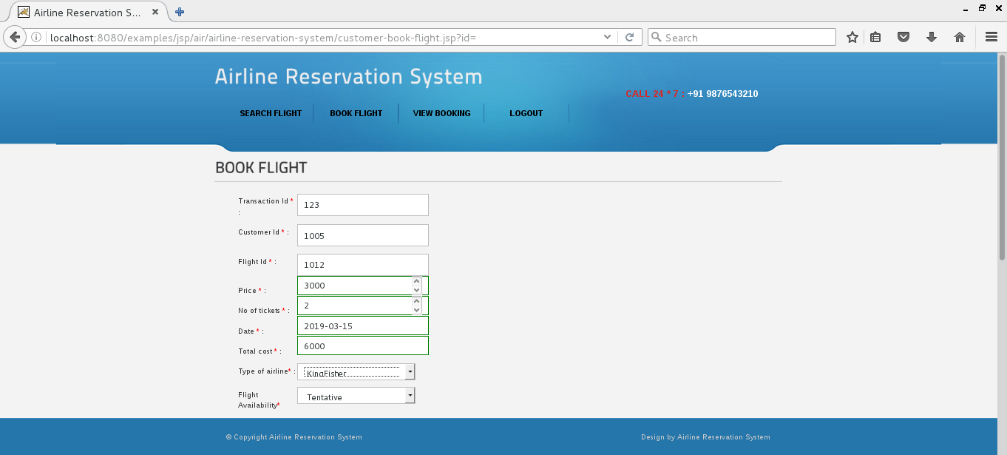

View Booking :-

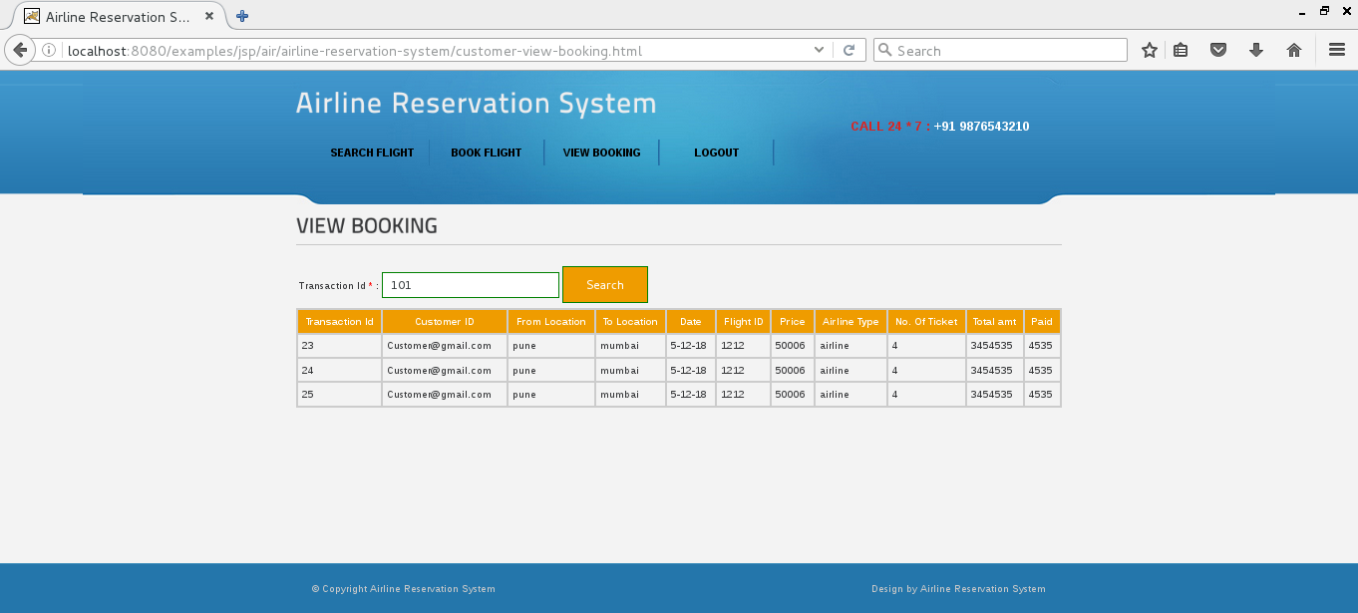

**FUTURE ENHANCEMENT**

Since the computer is performing all the computational work, no error or the negligible error introduced.

System has faster response time because of the operation performed by the computer.

System is user friendly and operates easily and effectively.

Multi user facility.

Security only for authorized person is provided

**BIBLIOGRAPHY**

**BOOKS**

**JAVA: COMPLETE REFERENCE BOOK**